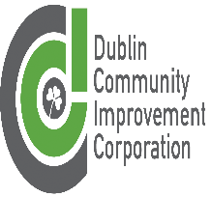**Dublin Community Improvement Corporation**

**Board Meeting Agenda**

February 24, 2025

5:00 p.m. Dublin Council Chamber Conference Room

1. **Call to Order**
2. **Roll Call**
3. **Review of Minutes from Previous Meeting** **(12-9-2024) (Motion)**
4. **Election of Officers**
5. **Accounting and Legal Services**
6. **Staff Comments**
7. **Board Roundtable**
8. **Adjourn**